

**D**esign **D**ocument **(DD)**

Computer Science and Engineering (CSE)

Software Engineering 2 Project

Year 2015/16

*Date: 04/12/2015 – Version: 1.0*



**STUDENTS:**

*Martino Andrea (****788701****)*

*Marchesani Francesco (****852444****)*

**PROFESSOR:**

*Mirandola Raffaela*

# Table of Contents

1. Table of Contents 2

2. Introduction 3

2.1. Purpose 3

2.2. Scope 4

2.3. Definitions, Acronyms, Abbreviations 4

2.4. Reference Documents 4

2.5. Document Structure 6

3. Architectural Design 7

3.1. Overview 7

3.2. Component View 9

3.3. Deployment View 10

3.4. Runtime View 10

3.5. Component interfaces 10

3.6. Selected architectural styles and patterns 11

3.7. Other design decisions 13

4. Algorithm design 13

5. User Interface Design 13

6. Requirements Traceability 13

7. References 15

7.1. References list 15

# Introduction

## Purpose

This **Design Document** contains information about the **architecture** and other features of *myTaxiService design* such as **high-level** **algorithms** and **user interface** (with recalls from the previous **RASD**). In order to maintain a **modular** and **scalable** system for the future, we will enter in details only if strictly necessary (otherwise, we will keep a higher level of abstraction).

This **document** is coherent with *the official template* of the project on the *Beep platform*.

As we said for the **RASD**, it is important to underline that some parts of this document may evolve in the future (this may occurs for several causes).

Anyway, we will try to maintain coherence as much as possible.

Here is a resume of the steps of the project, with the related deadlines (in green documents already delivered):

## Scope

The main scope of this **DD** (*Design Document*) is to give an overall guidance to the **architecture** of the **project**, which is *myTaxiDriver* (**Software Engineering 2 project** of year 2015/16 - **Politecnico di Milano**).

We described the main **goals** and **objectives** of the project in the previous *Requirements Analysis and Specification Document*.

## Definitions, Acronyms, Abbreviations

* **DD:** *Design Document*
* **RASD**: *Requirements Analysis and Specification Document*
* **mTS**: *myTaxiService*
* **JEE**: *Java Enterprise Edition*
* **UML**: *Unified Modelling Language*
* **Servlet**: A servlet is a program that extends the capabilities of a server.
* **Layer**: logical level of the architecture.
* **Tier**: physical level of the architecture.
* **Markov chain**: is a random process that undergoes transitions from one state to another on a state space.
* **M/M/s**: (also known as *M/M/k*) is a multi-server queueing model.

**Note:** *for the full Glossary may be helpful to see also the paragraph 1.5 of the RASD.*

## Reference Documents

The main reference document is the **Requirements Analysis and Specification Document (RASD)** of *myTaxiService*.

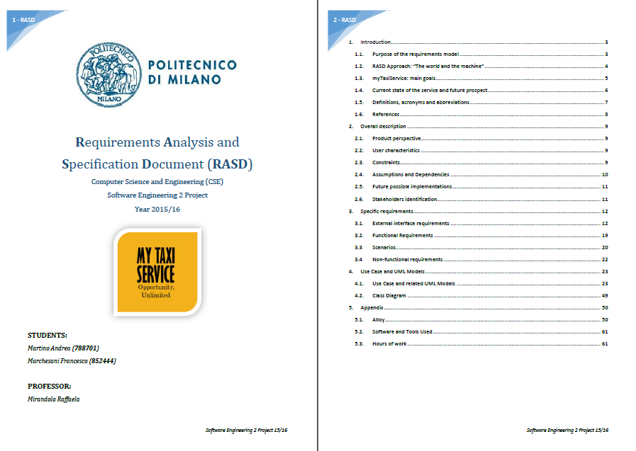

*Preview of the Requirements Analysis and Specification Document (RASD), our reference document.*

## Document Structure

The **Document Structure** completely follows the template hosted on the *Beep Platform* (PDF file *DD TOC – Design Document Template*).

# Architectural Design

## Overview

We start from a big consideration: *myTaxiService* is a big project. As we have seen before, in the RASD, we have a lot of potential users and a big amount of requirements.

Thus, we considered to develop our application using **Java Enterprise Edition** (**JEE**).

This will also be useful to satisfy important *Non-Functional Requirements* such as scalability, portability, availability, reliability and so on.

The applications of *myTaxiService* (the web application and the mobile one) will be *large-scale*, *multi-tiered, scalable, reliable* and the network will be *secure*.

The application developing takes as reference the standard of **Java Enterprise Edition 7** (**JEE7**), the last release available now.

We will use a *three-tier physical architecture* mapped on *four logical layers*, as the standard of JEE.

Here is the general schema of the **architecture**:

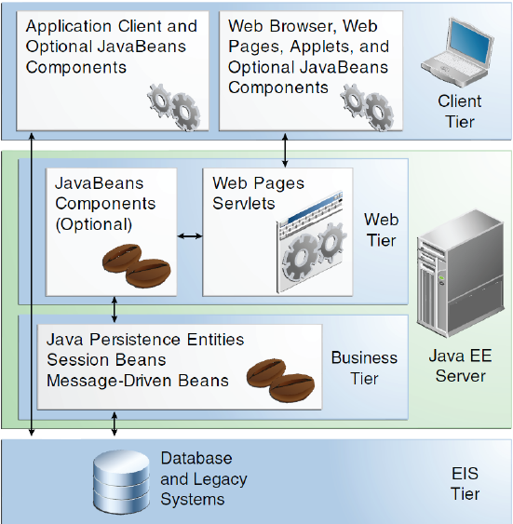

Now we will see in a deeper level of detail the meaning of each layer:

* **Client Layer**: it contains Application Clients and Web Browsers and interacts directly with the actors (Customers and Taxi Drivers). In our application, the Client can access via browser (*web application*) or via smartphone (*mobile application*).
* **Web Layer**: it contains the *Servlets* and *Dynamic Web Pages* that needs the elaboration. This tier receives the requests from the *Client* *layer* and forwards the pieces of data collected to the *Business Layer*.
* **Business Layer**: it contains the application logic (with the *Java Beans* and the *Java Persistence Entities)*. This will permit the communication between the System of mTS and the target users (Costumers and Taxi Drivers).
* **EIS (Data Layer)**: it will contain all the *data* concerning Costumers, Taxi Drivers, Calls, Reservations and other useful information. It is crucial to manage data according to strict policies about security and privacy.

It is important to underline that *myTaxiService* will also use external pre-built software products from the point of view of the business logic, such as **Google Maps** for the maps and the **online payment services API** (*e.g. PayPal*). We will cover this aspect in chapter *3.7 - Other Design Decisions*.

Here is a schema of the **three physical levels** (*tiers*) of the architecture:

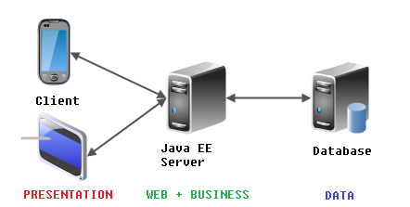

**Note:** *It is important to underline that both the Web Layer and the Business Layer are mapped on the same physical machine in our architecture (the Java EE Server).*

## Component View

According to JEE Standard, in order to develop a modular system that can evolve in future without big problems we decided to make use of a *Component-based approach*.

The formal definition of component is the following one:

*A* ***Component*** *"represents a modular part of a system, that encapsulates its content and whose manifestation is replaceable within its environment. A component defines its behavior in terms of provided and required interfaces"*

We selected the main components of *myTaxiService* project with respect to the architecture of *Java Enterprise Edition*. From the point of view of the *logical architecture*, we will have:

* **Client Components**
* **Web Components**
* **Business Components**
* **Enterprise Information System (EIS) Components**

**Note:** as said before, the *Web Components* and *the Business Components* will be embedded in one physical machine (*JEE Server*).

It is important to underline that the whole logic will run on the *Business Layer*, so the clients of the architecture are **thin** and not fat. We can see a little schema to clarify this notion:

Now let us make a distinction between the two macro-categories of Components:

* **Client-Side Components**: components located on the clients (*Taxi Driver View, Costumer View, SysAdmin View).*
* **Server-Side Components**: components located on the server (*Taxi Driver Manager, Costumer Manager, SysAdmin Manager, Queue Manager, Reservation Manager*).

There are also Component Interfaces. We will see the interfaces in detail in chapter *3.5 – Component Interfaces*.

Now let us define the **Components** of *myTaxiService*, with their functionalities:

**CLIENT-SIDE**

* **Costumer View**: this component is the one that directly interacts with the end-users. It allows the users to do all the actions about reservations (create a new one, delete, see the current price…), account managements (create an account, change password….) and so on.
* **Taxi Driver View**: this component represent what a Taxi Driver can see on his/her device. It is possible to see details about the reservations, the GPS position and so on.
* **SysAdmin View**: this is a very crucial component. The System Administrator can have a direct vision of the System through this view. Therefore, he/she can decide to modify the position of the taxi drivers in the zones, to check heterogeneous kinds of information and do technical operations.NEL CASO DA AGGIUNGERE IN RASD

**SERVER-SIDE**

* **Customer Manager**: this component manages the information about the Customers.
* **Taxi Driver Manager**: this component manages the information about the Taxi Drivers, with the current situation (and disposition in the areas).
* **System Manager**: this is a very important component. It interacts with the other pre-built software (like Google Maps and PayPal), performs the dispatching operations and permits to have a functional overall system. As we will see later, with the component interfaces, it is strictly linked to the other main components.
* **Reservation Manager**: this component manages all the operations about the reservation. For example, it traces the information about the reservations with the GPS positions, also when a reservation is deleted / updated. It works both for the “standard” reservation and for the LiveReservationsTM.
* **Queue Manager**: this component works on the queues in the different zones in parallel. It uses the *M/M/s model* presented in chapter *4 – Algorithm Design* to optimize the taxi distribution. It inserts the Taxi Drivers in different queues, updates dynamically the queues and do all the correlated operations. In special cases, the *SysAdmin* may change some parameters of the algorithm to optimize the model.

This is the **UML Component** **Diagram** related to *mTS* project:

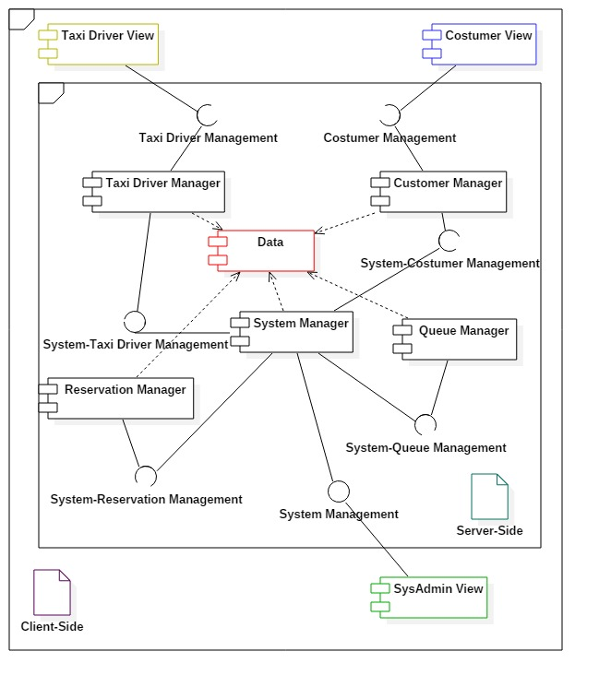

## Deployment View

We briefly discussed about the physical mapping of the logical architecture in the chapter *3.1 – Overview*. Since this aspect is very important, we will go into details with a **Deployment Diagram**, to give the physical deployment of components on physical nodes. In order to grant a *high level of security*, we will use both hardware and software *cryptography*, as said in the **RASD**.

This is the **UML Deployment Diagram**:

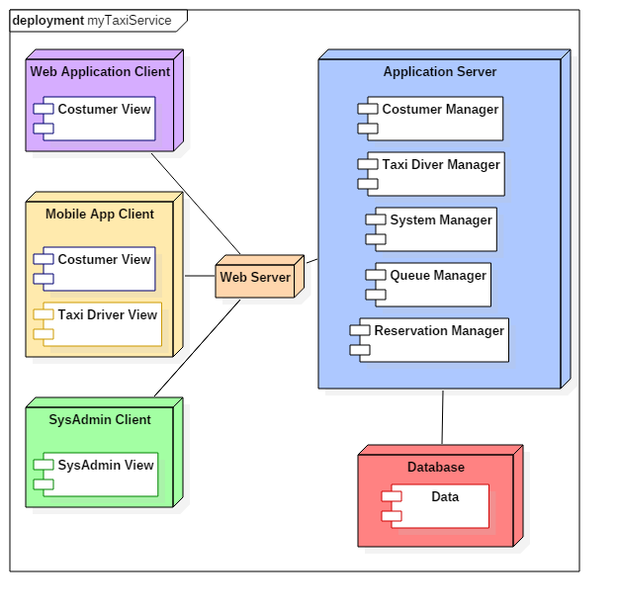

## Runtime View

## Sequence Diagrams Here

## Component interfaces

One of the most interesting aspect of the components is their interaction. We will see in this paragraph that they interact each other with ad-hoc interfaces. A big amount of interaction will be through the web. This means that the interactions will adopt specific protocols (like *TCP/IP, HTTPs*).

Anyway, this is the list of the component interfaces, with the explanation of the interactions between the components:

*** List of components + high level methods ***

## Selected architectural styles and patterns

### MVC (Model-View-Controller)

**Model-View-Controller** (also known as **MVC**) is one of the most diffused *structural pattern* in the applications with interfaces. It separates three logical parts: the **Model**, the **View** and the **Controller**. These parts interact each other according the following general schema:

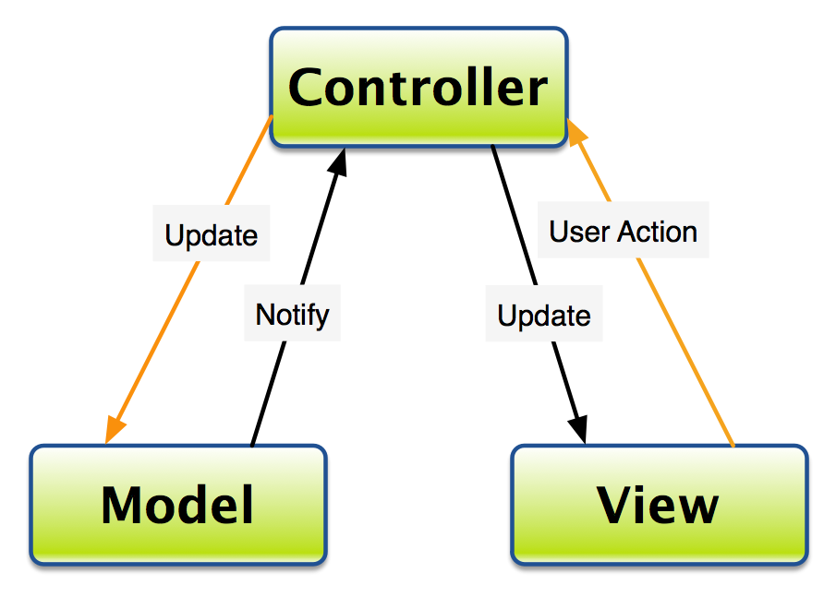

*Model-View-Controller general schema*

In the specific case of *myTaxiService* these three logical parts will have the following *roles* and *interactions*:

* The **Controller** sends commands to the Model to update the Model's state (e.g., editing tuple in mTS Database with a new reservation). It must also send commands to its associated view (the Taxi Driver or the Web/Mobile Costumer one) to change the View's presentation of the Model (e.g., by scrolling through a reservation form).
* The **Model** stores data that is retrieved according to commands from the Controller and displayed in the View. It contains all the data about reservations, Costumers, Taxi Driver and son on.
* The **View** generates an output presentation to the user based on changes in the Model. There will be three different types of View: *Mobile Costumer View, Web Application Costumer View and Taxi Driver View*.

### State pattern

The **State pattern** is a behavioral software design pattern, also known as the **objects for states pattern**. This pattern is used in computer programming to encapsulate varying behavior for the same object based on its internal state. Here is a general schema in *UML*:

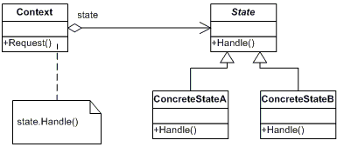

*State pattern general schema*

In the case of *myTaxiService* this pattern can be very helpful with the management of the **Taxi Drivers**. In fact, a Taxi Driver can be in different states from the point of view of the System.

Let us focus on the possibilities. The possible **states** of a Taxi Diver are:

* *At work – Available at the moment*
* *At work – Not available at the moment in the current queue*
* *At work – Currently moving to another area*
* *Not at work*

This will take trace of the status of any Taxi Driver during the whole day and can be used to compute the queue on the base of the available Taxi Drivers.

## Other design decisions

# Algorithm design

## Queue Management: M/M/s model

In order to explain the management of the queues it is important to recall the basics of the **M/M/s** model of **Queue Theory**. This recapitulation will also help future developers to understand the bases of the queue model of *mTS*.

We will not enter in details about the **implementation** of the model in our system with the source code of the **algorithm**, because it will only be a constraint for the successive phases of developing.

In fact, the **Design Document** must have a *higher level of abstraction*.

Anyway, it is good to give an idea of the Queue Management, with the right terminology and the basilar math notation. Here is a high-level schema of *myTaxiService* Queue Model:

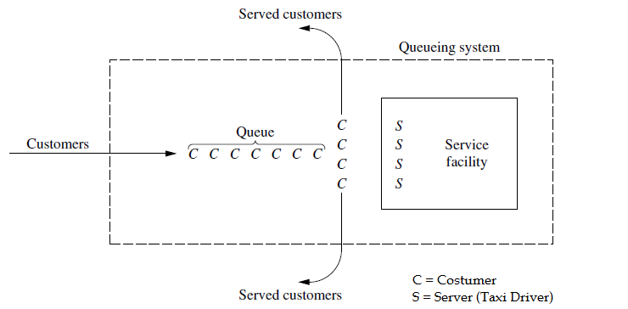

**Model Assumption**: *interarrival times* and *service times* are identically distributed according to an *exponential distribution.*

Now let us define the probabilistic variables and constants of this model in a formal way:

* **State of system** = *number of customers in queueing system.*
* **Queue length** = *number of customers waiting for service to begin.*
* **N(t)** = *number of customers in queueing system at time t (t ≥ 0).*
* **Pn(t)** = *probability of exactly n customers in queueing system at time t, given number at time t0 = 0.*
* **s** =*number of servers (parallel service channels) in queueing system.*
* **λn** = *mean arrival rate (expected number of arrivals per unit time) of new customers when n customers are in system.*
* **µn** = *mean service rate for overall system (expected number of customers completing service per unit time) when n customers are in system. Note:* ***µn*** *represents combined rate at which all busy servers (those serving customers) achieve service completions.*
* **Pn** = *probability of exactly n customers in queueing system.*
* **L** = *expected number of customers in queueing system.*
* **Lq**= *expected queue length (excludes customers being served).*
* **°W** = *waiting time in system (includes service time) for each individual customer.*
* **W** = *E(°W), where E() is the expected value.*
* **°Wq** = *waiting time in queue (excludes service time) for each individual customer.*
* **Wq** =*E(°Wq), where E() is the expected value.*

To simplify the notation, we define some support variables:







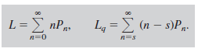





Now let us introduce the **Markov Rate Diagram** before the final formulation:

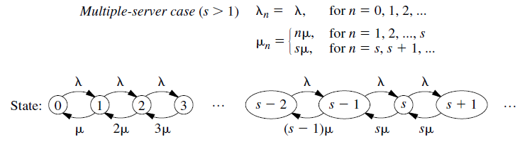

This is very useful to give an idea of the probabilistic states of the **Taxi Queues**, according to *Markov chains* notation.

Now let us give a **closed formulation** of the useful terms of the model:

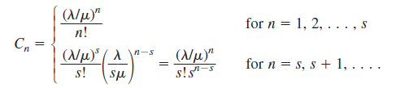

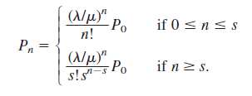









The probability distribution of waiting time is represented by the following formulae:

**Service Time Included**



**Service Time Excluded**



Where:

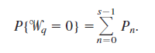

In our model, we assume that all the **areas** have the *same exponential distribution of reservations*. This may be a good assumption in practice if the area are “*balanced*”.

However, we plotted on two different graphics some interesting results of the **M/M/s model** of *Taxi distribution.*

The **first one** is the *steady-state probability of zero costumer in the system (P0)* as a function of the *servers* (*s, Taxi Drivers*) and the *Utilization factor (ρ)*.

The **second one** is *steady-state expected number of customers in the system* *(L)* as a function of the *servers* (*s, Taxi Driver*) and the *Utilization factor (ρ).*

Anyway, sometimes graphics are better than words. Therefore, here is the two probabilistic graphics, as promised before:

1. *Steady-state probability of zero costumer in the system (P0) as a function of the servers (s, Taxi Drivers) and the Utilization factor (ρ).*

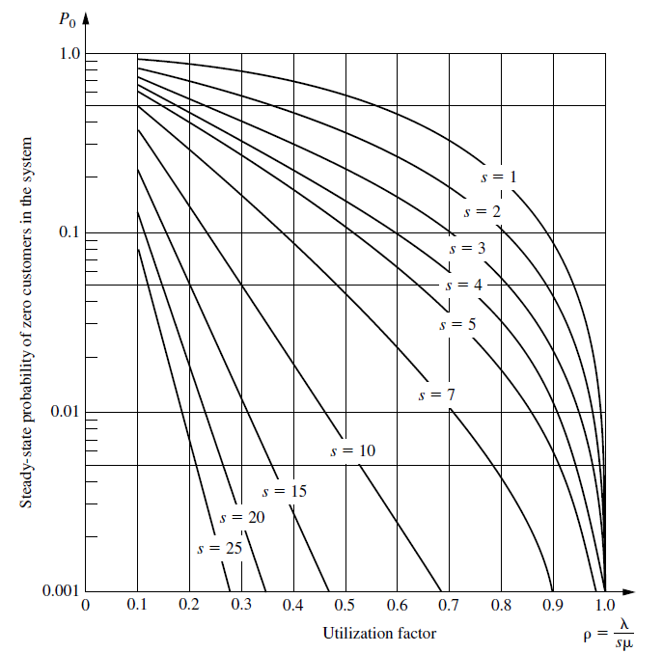

1. *Steady-state expected number of customers in the system* *(L)* as a function of the *servers* (*s, Taxi Driver*) and the *Utilization factor (ρ).*

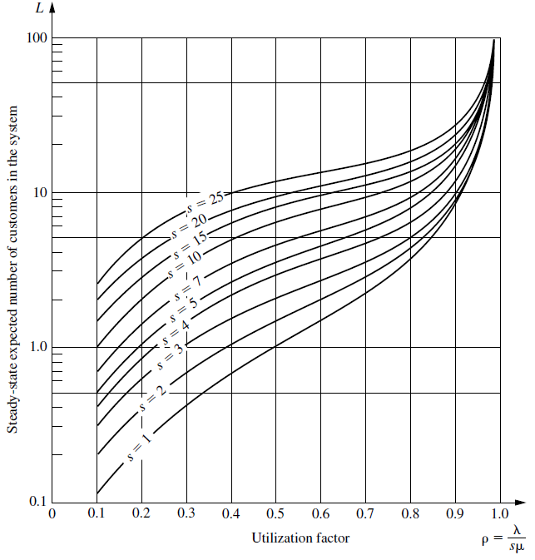

# User Interface Design

*User Interface* plays a very important role in interactions between machines and humans. Given that we have assumed that *no special skills are requested* to use mTS product, UI must be kept as simple as possible without sacrificing functionality.

In RASD we have provided some mockups to give a general idea of myTaxiService application using visual elements like *buttons*, *form*, *pages*, etc. Now we would like to show some UX Diagrams to have a more abstract model. We encourage you to keep on hand mockups during the reading of this paragraph.

## Passenger Application

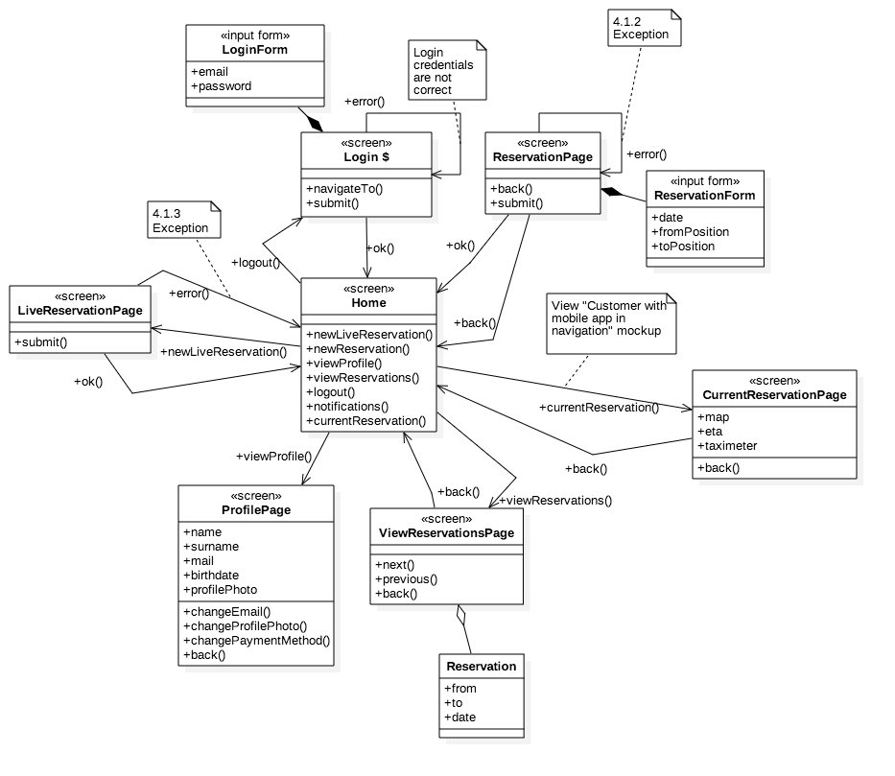

As you can see there are some references of exceptions that can occur in some use cases.

## Taxi Driver Application

As we have said in RASD interaction between taxi driver and driver application is very limited. In fact driver can only see driving directions provided by the system and confirm/decline requests to take care of a reservation.

Please, excuse our UML representation of this particular diagram. With *“map component”* we actually mean something that is showed over the map piece of the main screen and with *“banner”* we mean something that partially overlays the main screen.

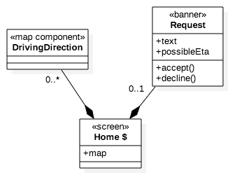

//DA FARE ANCHE WEB UTENTI?

# Requirements Traceability

|  |  |  |
| --- | --- | --- |
| Requirement | Component | Description |
|  |  |  |
|  |  |  |
|  |  |  |
|  |  |  |
|  |  |  |
|  |  |  |
|  |  |  |

# References

## References list

Here is a short list of the **references** for this **Design Document**:

* *Slides of the Software Engineering 2 course (from the* ***Beep Platform****)*
* *Design Document Template* *(by Prof. Raffaela Mirandola)*
* *Software Engineering: Principles and Practice (Hans Van Vliet)*
* *UML Distilled (Martin Fowler)*
* *Introduction to Operations Research (Frederick S. Hillier, Gerald J. Lieberman)*
* *Wikipedia*

## Hours of work

* **Andrea Martino**: Hours
* **Francesco Marchesani**: Hours